

American International University- Bangladesh

CSC 4261: Advanced Programming in Web Technology

CO1 Evaluation

Project Report

Fall 22-23

Project Title: Car Rental Management System

Project Domain: Business to Business Services

Group Number:

Section: A

|  |  |
| --- | --- |
| Student Name | Student Id |
| MD REDOY SHEIKH | 19-40101-1 |
| S.M. SHAHRIAR | 19-39596-1 |
| KHAN, MANSIB AHSAN | 19-40093-1 |
|  |  |

**Introduction:**

Our general purpose is to create a car rental management system that benefits both the renter and the provider. In our city, someone might own many vehicles that they aren't using, allowing them to rent them out to others who might want to use them for his or her requirements at a specific moment.

**Problem Analysis:**

In our city, someone might own many vehicles that they aren't using & on the other hand someone might not have enough money to buy a new car. Those who own multiple unused cars can post their unused cars on this site as a rental option. & Those who don't have enough money to buy a new car or don't want the hassle of buying a new car and don't want the hassle of making car documents. They can rent their desired cars for a specific time period. For the customer, money and time can both be saved.

Examples of existing Solutions:

1. Website Reference: <https://itsourcecode.com/free-projects/laravel/complete-car-rental-management-system-in-laravel-with-source-code/>

Description: This Car Rentals Agency is a web application built using the Laravel framework and core PHP, with expressive and clean syntax. It takes the hassle out of renting a car by making routine chores in the agency easier, such as: Customer registration: new users are be able to register online and print a membership card. Automatic database update if a reservation is made or a new customer is registered. Customer feedback: There is a way for customers to provide feedback

1. Website Reference: <https://www.yahoobaba.net/project/car-rental-project-in-laravel>

Description: This Car Rental System is a Laravel based script which is useful for vehicle rental system. It offers awesome design, powerful display and built on HTML5 & CSS3, Bootstrap and much more.

**Feature Analysis:**

1. **User Category:**

There are 3-types of Users here. They are:

* Admin
* Renter
* Customer

1. **Feature List:**

In this project the “Admin” has the following features:

* Login
* Block Control
* Renter Service Request Approve/Deny
* Add User
* Edit User
* Delete User
* Rent History Manage
* Post Notice
* Renter Service manage
* Customer Review manage
* Message

In this project the “Renter” has the following features:

* Registration
* Login
* Add Car Service
* Edit Car Service
* Delete Car Service
* Customer Service request Approve/Deny
* Message
* Check History
* Update Profile
* Post and delete Car Video

In this project the “Customer” has the following features:

* Registration
* Login
* Edit Profile
* Post for car
* Edit post
* Delete post
* View Available Cars
* Order Car Service
* Cancel Service order (before renter approves)
* Check history
* Message
* Check Notice

**Design:**

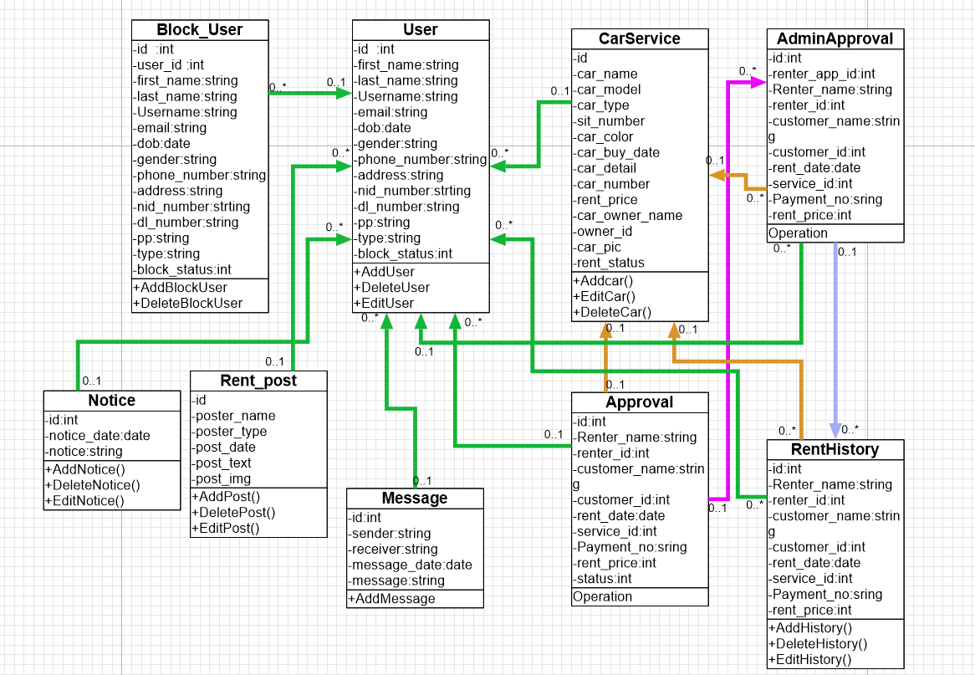

Fig: Class Diagram

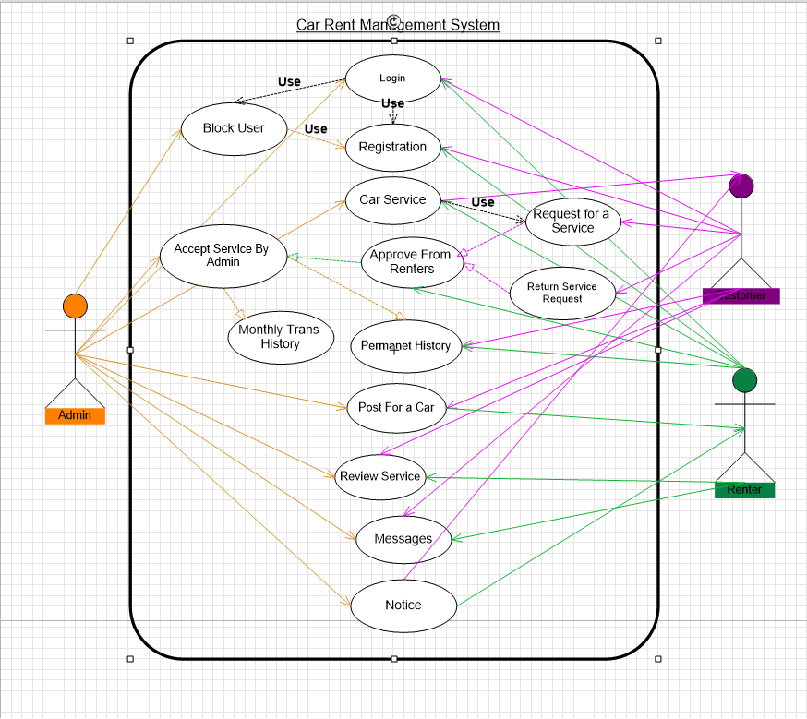

Fig: Use Case Diagram

**Tools Used:**

To develop this project, we have used the following:

• Laravel

• HTML

• Bootstrap

• CSS

• MySql

• Dia

**System Images against the Specification:**

|  |  |  |
| --- | --- | --- |
| ADMIN | RENTER | CUSTOMER |
| This is an admin dashboard page. Where admin can control few functionalities, such as block user. | Here, in this page one renter can edit & delete his proposed car for rent. | Here, in this page one customer can edit & delete his post. |
| This is a page for conversation between two people. | Here, in this page, one renter can edit his posted car for rent. | Here, in this page one customer can view & search for all the available cars for rent in the system. |

**Impact of this Project:**

Our general purpose is to create a car rental management system that benefits both the renter and the provider. In this System Renter User Who have extra cars can rent through this system and earn while Customer user can order rent car with a reasonable price and go to their destination.. In our country’s perspective it is difficult for most of the people to buy a new car & making paper & documents for the car is another hassle. For this system it will release few of the pressures from the customers. Customers will be benefited by time & money. On the other hand, Car providers will be benefited financially.

**Limitations and Possible Future Improvements:**

In Bangladesh perspective, it is difficult to develop a management system. It might be difficult to satisfy everyone by this system & the security & freshness of the car might get hamper. On this website we could add more security and more document Scannable options. It might be hard to give conditions to the users about not to harm his/her rented car. We might face few limitations in the security purpose of the car too. The possible future improvement to our system could be generate few more important security features to improve the security side of the car.

|  |  |  |  |
| --- | --- | --- | --- |
| CO1 Evaluation: Project Report Evaluation | | | |
| Problem  Analysis  (5) | Use Case  Diagram  (5) | Class  Diagram  (5) | Total (15) |
|  |  |  |  |
|  | | | |